1. 
2. Earlier, we store blobs and trees directly into the Git Repository using low level commands such as hash-object (for git blob), mktree (for git tree)
3. 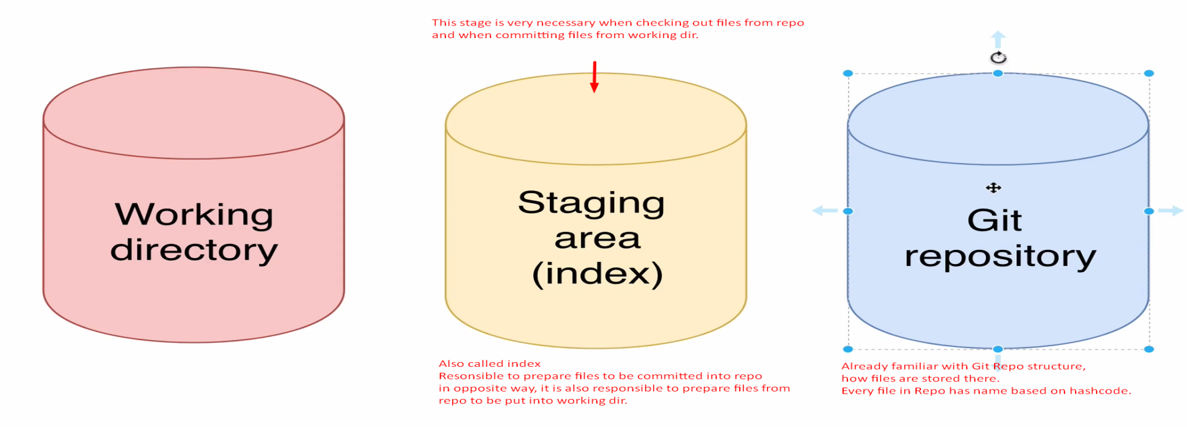
4. **Terms**:
   1. Working Directory, Staging Area (also called index), Git Repository.